Crust
The crust is the first layer of the earth. It is split up into two parts the continental crust, and the oceanic crust. The oceanic crust takes up 71% of the earth’s crust, and the other 29% of the crust is continental. The continental is made up of igneous rocks, and the oceanic crust is made up of sedimentary and basalt rocks. The crust is the layer were tectonic plates can be found.
Igneous rocks are those that solidify from the cooling and hardening of Magma. Magma is molted (melted) rock under the surface of the Earth.
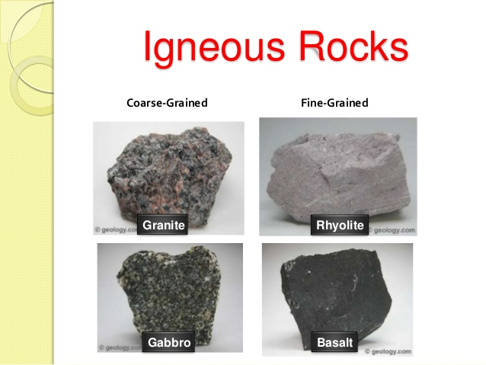

Basalt rock is characteristically a dense, black, massive rock, high in calcium and iron-magnesium- bearing minerals and low in quartz content.
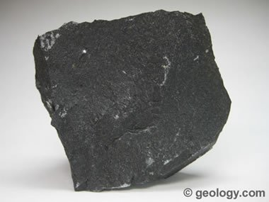
Sedimentary rocks are formed from pre-existing rocks or pieces of once-living organisms. They form from deposits that accumulate on the Earth's surface. The sediment is compressed over a long period of time before consolidating into solid layers of rock.
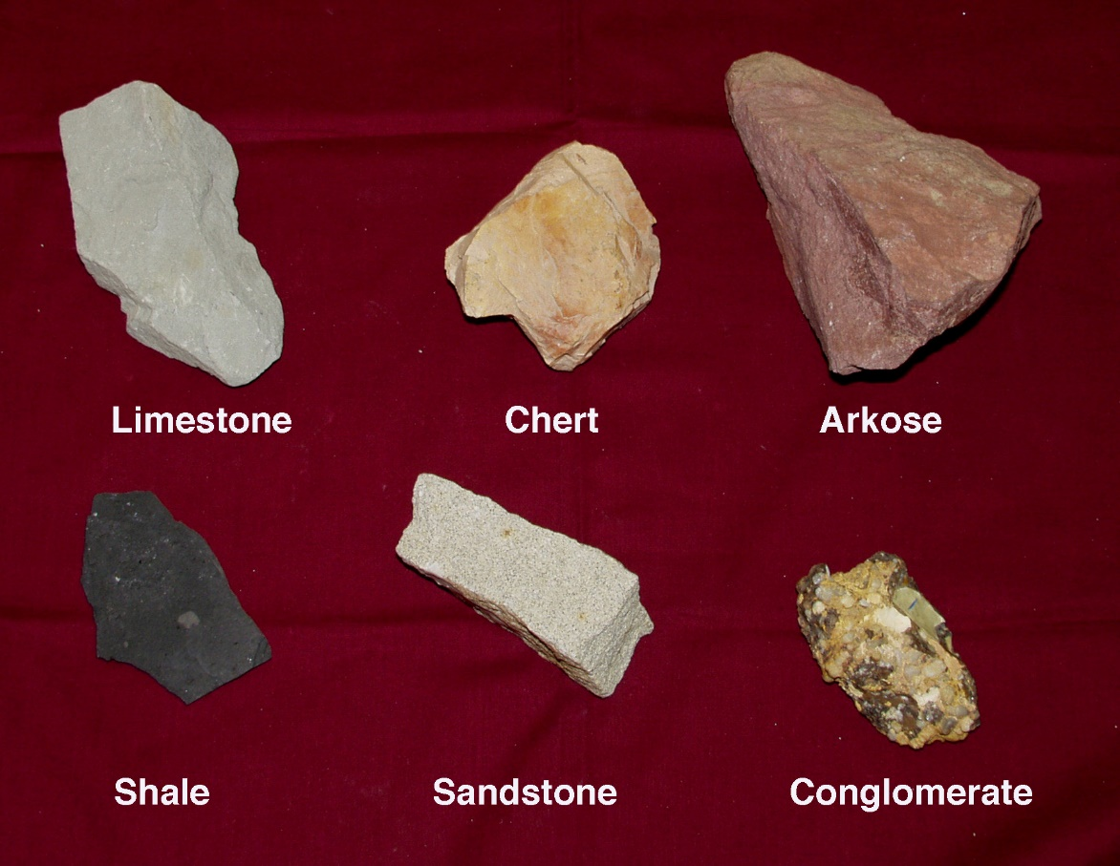

Mantle
The mantle is the second layer of the earth. It is split up into two different parts, the lithosphere (which is the top part) and the asthenosphere (which is the bottom part). The lithosphere is a dense rock made out of iron and nickel, the asthenosphere is a plastic like fluid.
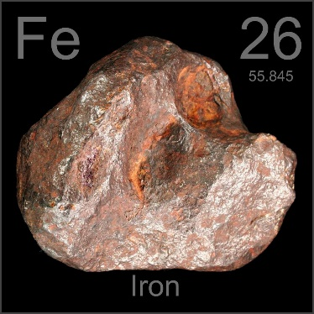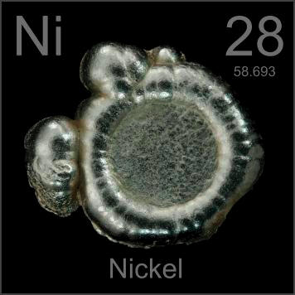

The mantle has the biggest volume of all the layers, the volume of it is 84% of the earth. It is 1,800 miles deep or 2,900 kilometers deep.
Outer core
The outer core is a liquid made up of iron and nickel. The temperature of the outer core is around 4400 degrees Celsius. The depth of the outer core is 2, 890. This is one of the three layers that is putting pressure on the inner core. It is the second hottest layer.

Inner core
The Inner crust is the second thinnest layer. The inner core is hotter than the surface of the sun. The inner core is made out of iron and nickel. It is 5159 to 6378 km thick. The inner core is extremely hot and is the last layer. The inner core is 5505 degrees Celsius. It is a solid ball of Iron metal.

how do scientists know how hot Earth's core is? They can't see it. They can't dig down deep enough to use a thermometer to measure its temperature.
The fact that Earth has a magnetic field tells us that it's iron and that part of it is molten. Without at least a partially liquid core, convection wouldn't occur, making it impossible for a planet to form a magnetic field.
